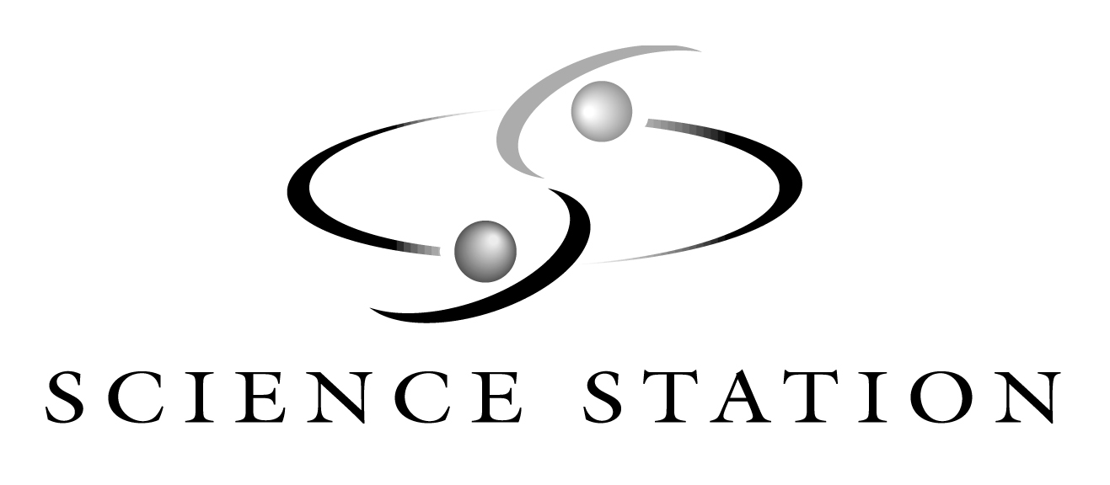
PROGRAM GUIDE: ELEMENTARY LEVEL
(GRADES K-5)

Science is fun at the Science Station! Push, pull, test, explore, observe, and think in an atmosphere that encourages hands-on learning. Our mission is to provide entertaining learning experiences that inspire our visitors and spark their imaginations. Come explore our content-rich exhibit collection, experience one of our outstanding educational programs, and see a large-format film in the IMAX® Dome Theatre.

PROGRAM OPTIONS:

- Self-Guided Museum Visit: Explore our four exhibit galleries, stocked with over 100 hands-on science exhibits. Your students will have so much fun they won’t realize they’re learning! Engage your students in active learning with our exhibit scavenger hunt, available on the main program page as Science Station Investigation. We suggest you allow 2 hours for a museum visit.
Group Rate: Child - $4.05
Teachers and chaperones are admitted free to Science Station. One teacher/chaperone per 10 children is required.

- Educational Programs: Increase the educational impact of your students’ visit to Science Station by attending an educational workshop. Our programs inspire students to explore science by providing content-rich, hands-on activities. Workshops are 45-minutes in length, groups larger than 25 students may require additional sessions. Minimum class size 10 children. Program descriptions are listed below.
Group Rate: Program only - $3.00 per child
Program and museum combo - $5.00 per child
One teacher/chaperone per 10 children is required.

- Outreach: Would you like us to come to you? Please see the Outreach Program Guide on the Science in Transit webpage.

- IMAX® Dome Theatre: Wow your senses in the IMAX® Dome Theatre. The 50’ x 60’ screen and the 10,000 watt digital sound system make you feel like you’re in the center of the action. IMAX® film presentations are one-hour in length; groups exceeding 170 people will require additional time. Please call (319) 363-4629 ext. 30 for available films and show times.
Group Rate: Child: Adult:
IMAX® Only: $4.50 $6.50
IMAX® and Museum: $5.50 $6.50
IMAX® and Program: $5.50 $6.50
IMAX®, Program and Museum: $6.50 $6.50

FOR RESERVATIONS:

Reservations and payment are required in advance for all Science Station group visits. Early booking for spring dates is strongly recommended. To make a reservation, please call our registrar at (319) 363-4629 ext. 30. The registrar is available between 7:30 AM – 3:30 PM, Monday-Friday; voice mail is available 24 hours a day.

PROGRAM DESCRIPTIONS:

Every scientist has a favorite area to explore, be it dinosaurs, bubbles, or space. Choose a topic from our list below and get ready to discover with us!

- GRADES K-2ND
Floods & Suds: Get your hands wet and have some good, clean fun exploring surface tension and bubbles. Make a jar of bubble solution and design your own bubble wand to take home for more fun. Max: 50 students per session (in 2 groups of 25)
Cloud Catchers: That’s not cotton candy in the sky! Discover what clouds are made of and create a cloud right in our classroom. We’ll learn how to use clouds to forecast the weather, too. Make your own cloud watcher to take home. Max: 50 students per session (in 2 groups of 25)
IMAX® Adventures: Take your IMAX® experience one step further and join us for fun, hands-on activities that complement the topic of our featured film. Max: 50 students per session
Body Works with Stuffee®: Stuffee® is an appealing, overstuffed character who turns “insides out” to reveal fascinating soft-sculptured organs. He is a wonderful way to introduce our youngest scientists to the wonder of the human body.
What is all that stuff in your insides? Each of our organs has a special job to do to make our bodies work. We’ll explore breathing, digestion, and circulation with Stuffee®. See and touch soft, colorful reproductions of our internal organs.
Healthy Snacks, Healthy Kids: Stuffee® knows that good food does a
body good. Explore the food pyramid and food groups, check out Stuffee’s
lunchbox to choose well-balanced snacks and meals, and try some delicious and healthy foods. YUM!

- GRADES 3-5
Current Events: Explore a shocking topic! Learn about static and current electricity and explore parallel and series circuits. Max: 30 students per session
Music to My Ears: Bang, beat, strum, and shake to make music! Investigate sound waves, experiment with vibrations, and learn about pitch and volume. Max: 30 students per session.
Take Flight: Become test pilots and explore flying objects. Discover the forces of flight and engineer your own flying machine. Max: 50 students per session.
Super Structures: Take the challenge and design the best tower. Find the most stable shapes and work as a team to build a successful structure.
IMAX® Adventures: Take your IMAX® experience one step further and join us for fun, hands-on activities that complement the topic of our featured film. Max: 50 students per session.

- PLANETARIUM PROGRAMS
Get ready to hear oohs and ahhs as you crawl into the Big Silver Bubble, otherwise known as our Starlab Portable Planetarium. This inflatable dome is transformed into a wondrous, star-filled sky where your students can practice star-finding skills and hear legends of ancient cultures. The planetarium is wheelchair accessible. You’ll need an 11 foot ceiling and 24’ x 24’ of floor space in a quiet spot to have the planetarium visit your site.
Legends of the Night: Gaze at the stars and listen to wonderful stories. This program highlights the myths told by ancient civilizations to explain the patterns of the stars, as well as to explain their worlds. Many of the constellations recognized by astronomers today have their beginnings in this cultural heritage. Respect for cultures and beliefs that may be different from our own is stressed. Suitable for all grade levels. Select Greek, Native American, or Egyptian stories. Max: 25 students per session.
Iowa Skies: Learn patterns while discovering constellations. Custom-designed instruction lets students to see the night sky as it would appear on the date of their program. Students will learn to read star-maps and identify seasonal constellations. Recommended for 4th – 5th. Max: 25 students per session
Seasons of the Sun: Why are there seasons? Chart the progress of the sun through an entire year and discover how the sun’s rays make our seasons. Learn about orbits and seasonal constellations. Recommended for 5th grade. Max: 25 students per session.

